1.What is the purpose of the core module in AEM?

**Ans:** It contains the Java logic for AEM components and it also includes backend logic such as business rules, Sling models, and services that are used in the frontend components.

2.What kind of files and code can be found in the core folder?

**Ans:** It has Java files for Sling models, services, servlets, and OSGi configurations which defines how components behave and interact with data.

3.Explain the role of ui.apps in AEM projects.

**Ans:** It contains the front-end part of the project, like components, templates, client libraries and configurations that needed for the website.

4.How are components structured in the ui.apps folder?

**Ans**: Inside ui.apps, components are stored in /apps/project-name/components. Each component has an HTML file and JavaScript and CSS for styling.

**Hello World Component:**

5.Where is the Hello World component located in both core and ui.apps?

**Ans**: In core it is located in com.project.core.models as a Java class.

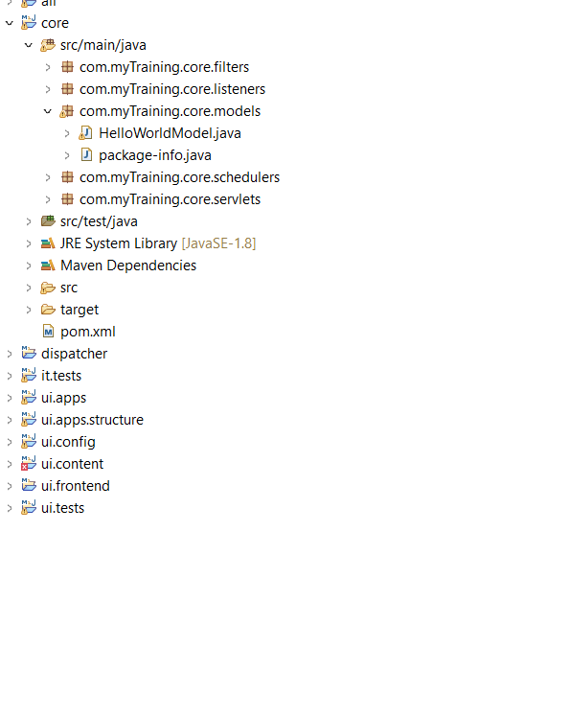

In ui.apps it is located in in /apps/project-name/components/hello-world.

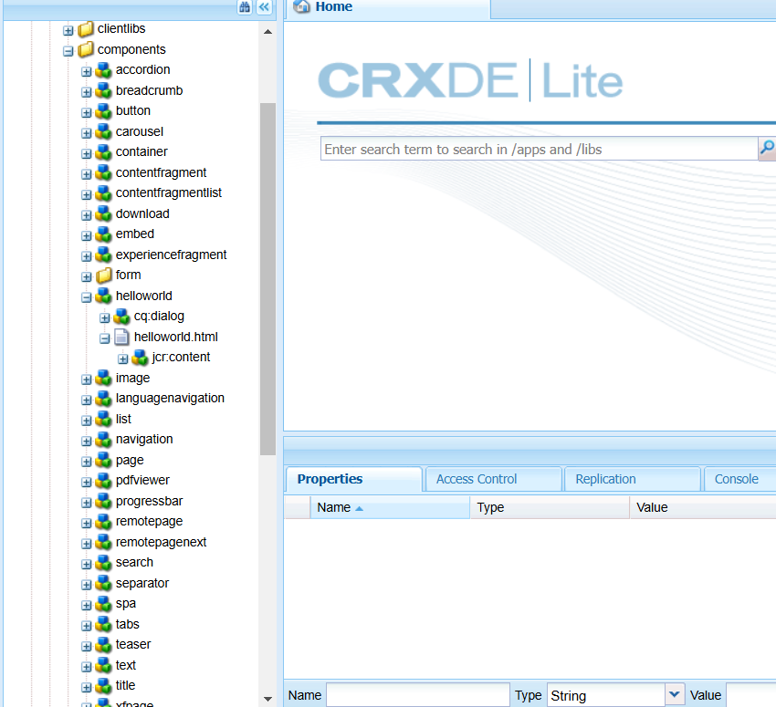

6.Explain the Java class (in core) for the Hello World component.

**Ans:** The Java class is a Sling Model that retrieves data from AEM and makes it available to the HTL file. It also has getter methods to return the values.

7.How does the HTL script work in ui.apps for Hello World?

**Ans:** The HTL file (.html) in ui.apps displays the output by calling the Java class methods using ${model.methodName}.

8.How are properties and dialogs defined for this component?

**Ans:** Properties are stored in .content.xml files, and dialogs are defined using XML (cq:dialog) inside the component folder**.**

9.What are the different types of AEM modules (core, ui.apps, ui.content, etc.)?

**Ans:** Core module, ui.apps module, ui.config module, ui.test module, all module

10.How does Maven build these modules?

**Ans:** It compiles Java code, processes HTL scripts, and packages everything into deployable AEM bundles (.jar or .zip).

11.Explain the build lifecycle of Maven in the context of AEM.

**Ans: Validate-**It checks the project setup**, Compile-**It Compiles java code, **Test-**Runs tests,

**Package-**It creates the build package,

**Install-** It adds the packages to local Maven repository**, Deploy-**It deploys to AEM

12.How are dependencies managed in pom.xml?

**Ans**: Dependencies are defined in pom.xml. It tells Maven what libraries and AEM APIs are needed.

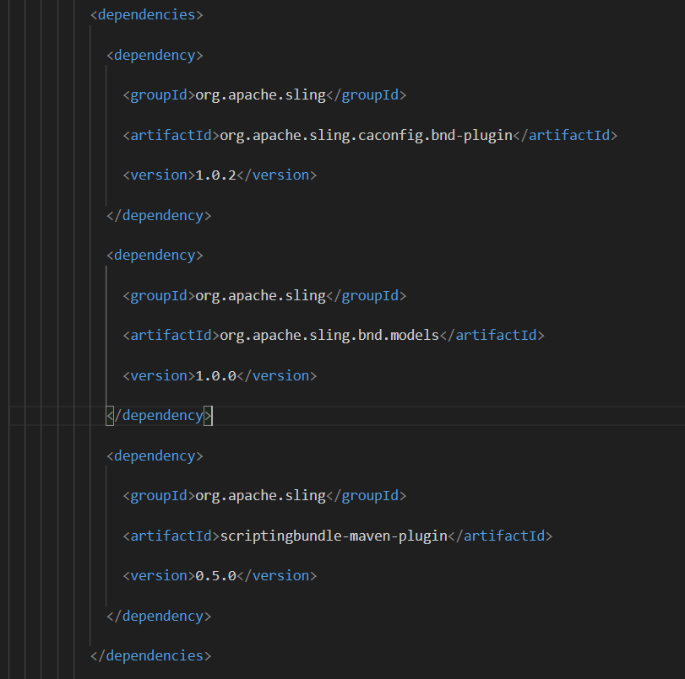

13.Why is Maven used instead of other build tools?

**Ans:** Maven is preferred because it automates dependency management, builds, and deployment. It also supports AEM-specific plugins.

14.What advantages does Maven offer for AEM development?

**Ans:** Supports version control, Integrates well with AEM

15.How does Maven help in managing dependencies and plugins in AEM projects?

**Ans:** Maven downloads required dependencies and includes plugins (like the AEM Plugin) to automate builds, tests, and deployments.

16.What does mvn clean install do in an AEM project?

**Ans:**  **mvn clean –** Deletes old build files**, mvn install –** Compiles, packages, and installs the project in the local repository.

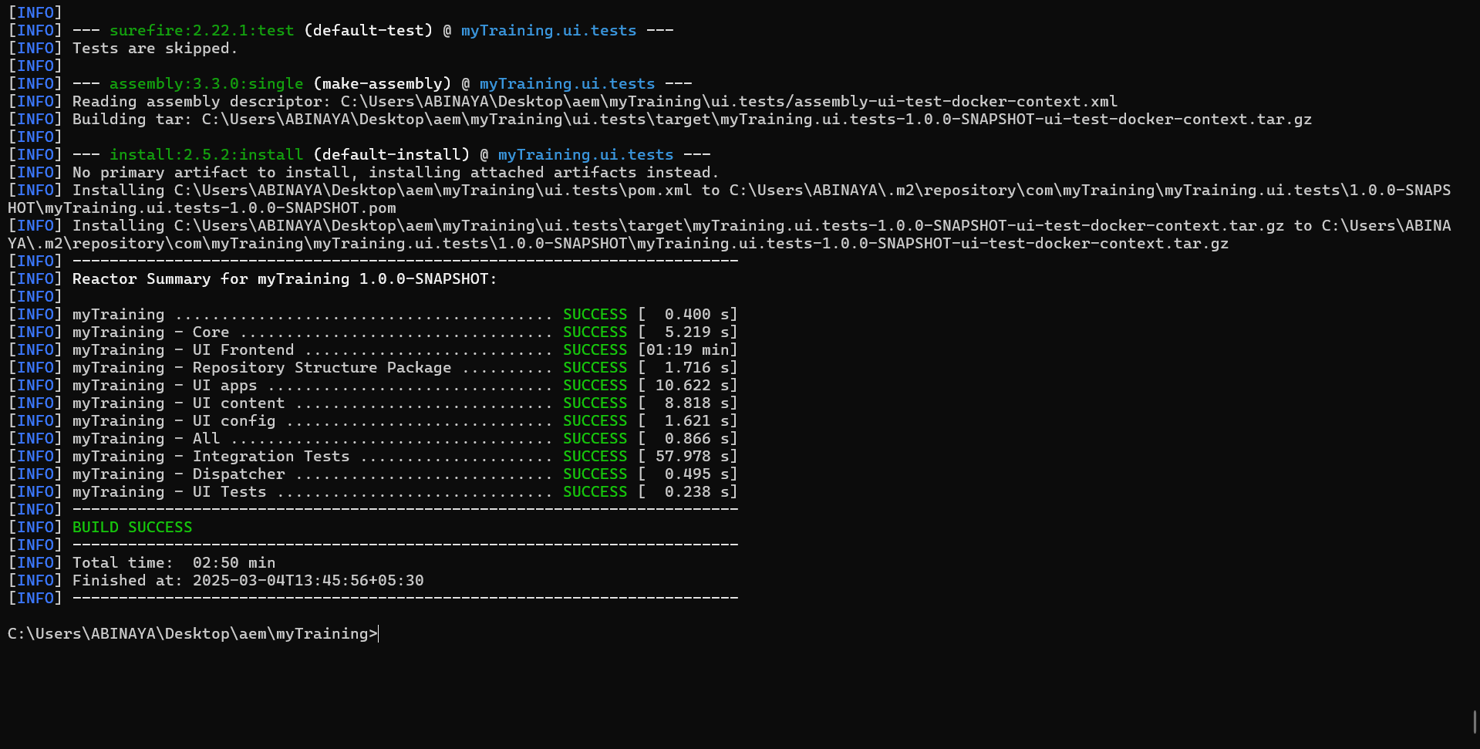

17.How to deploy packages directly to AEM using Maven commands?

**Ans:** mvn clean install -PautoInstallPackage

18.Explain the purpose of different Maven profiles in AEM (autoInstallPackage, autoInstallBundle).

**Ans:** **autoInstallPackage –** Deploys the full package**, autoInstallBundle –** Deploys only thebackend Java code

19.What is the purpose of dumplibs in AEM?

**Ans:** dumplibs helps debug and check client libraries .

20.How can you view client libraries using dumplibs?

**Ans:** By using this url<http://localhost:4502/libs/granite/ui/content/dumplibs.html>

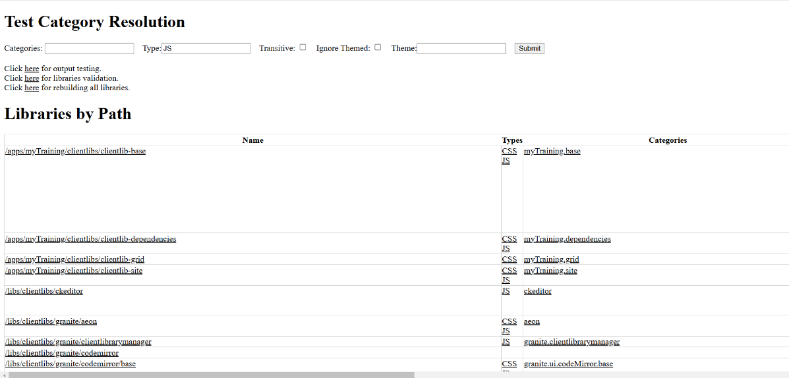

21.Explain how client libraries are structured in AEM.

**Ans:** Client libraries are stored in /apps/project-name/clientlibs and contain CSS, JavaScript, and dependencies. They are used to style and add functionality to AEM pages.

